Attendance counts

Regular school attendance is an important part of giving your child the best possible start in life.

Talking to your child and their teachers could help solve any problems you may have in getting your child to go to school and there are other forms of support available if you still have problems.

The law requires parents to make sure their children receive full-time education suitable to their needs. As a last resort, schools and the Education Welfare Authority have legal powers to deal with persistent absence (ie under 90% attendance).

How parents can help with attendance
- Establish a good routine in the mornings and evenings so your child is prepared for the school day ahead.
- Make sure your child goes to school regularly and follows the school rules.
- Ensure your child arrives at school on time – not late.
- Arrange dental and medical appointments outside school hours when possible.
- Always inform the school if your child is absent due to illness.
- Take truancy seriously – if your child is not attending school as you expect they may be putting themselves at risk – Who are they with? What are they doing?
- Take family holidays outside term time.
- Talk to your child about school and take an interest in their school work.
- Attend parents’ evenings and school events.
- Praise and reward your child’s achievements at school.
- Discuss any problems or difficulties with the school – staff are there to help and will be supportive.

What the law says about attendance
As a parent, you are legally responsible for making sure your child attends school regularly unless you provide evidence for absence.

Missing school causes severe disruption to a child’s education, and affects their performance in exams and chances later in life.

Penalty notices and prosecution
Schools, working in conjunction with the Local Authority may decide to give you a penalty notice if your child regularly misses school and you have not taken action or asked for help. If you are found guilty of an offence you may be prosecuted and fined up to a maximum of £2500.

Education is not an option – it’s compulsory.

Family holidays
You can demonstrate your commitment to your child’s education by not taking holidays during term time. Any child who is absent from school due to a holiday will miss out on important learning and will fall behind with their school work.

In each Academic Year there are only a maximum of 190 statutory school days – this allows plenty of time for holidays to be arranged outside term time.

Holidays taken during term time will be categorised as an unauthorised. The Local Authority can give each parent a fixed penalty fine of £60, which rises to £120 if you don’t pay within 21 days. If you don’t pay the fine after 28 days you may be prosecuted for your child’s absence from school.

Every School Day Counts

Every single day a child is absent from school equates to a day of lost learning.

For some parents, 90% may seem like an acceptable level of attendance, but the reality is that 90% attendance means that your child will miss half a school day each week or 19 days of school during the school year – that’s nearly 4 school weeks.
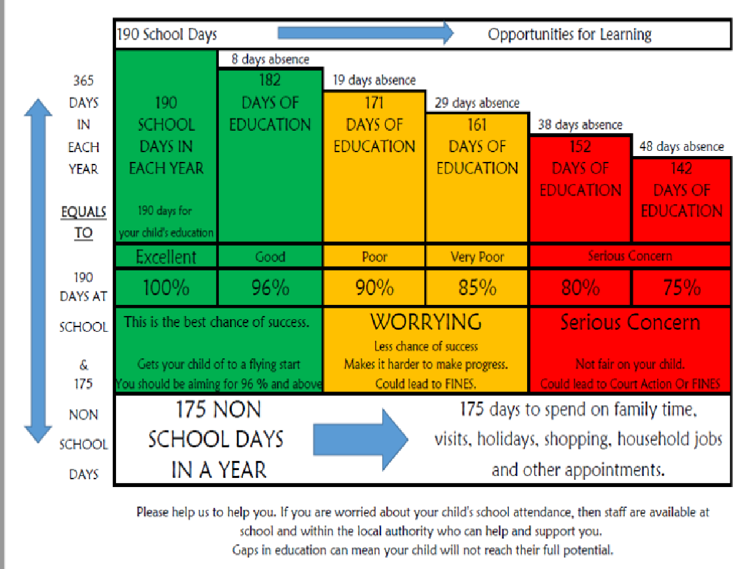

Punctuality Counts
Why is Punctuality Important for your child?

Being on time:

- Gets the day off to a good start for students and puts them in a positive frame of mind, so that they can make the most of all their learning opportunities.
- Sets positive patterns for the future. You can't expect to keep a job if you're always coming in late!
- Leads to a good attendance record.
- Leads to better achievement because they attend the whole of the class.
- Leads to understanding that school is important and education is valuable.
- Helps develop students’ sense of responsibility for themselves and towards others and is a sign of good character.
- Is respectful to their teacher and their fellow students as arriving late causes disruption to the whole class.
- Research shows that attendance and punctuality are the single most important factors in school success.

At The GFM all students are expected to be in school in good time for tutor time when they are registered. We suggest 8.15am is a good time to arrive.
There is a warning bell sounded at 8.25, then the registration bell at 8.30 when the register is taken promptly in tutor bases.

What happens if a student is late?
• If a student arrives late, a text message will be sent home informing parents that their child has arrived late to school.
• If lateness persists the school will make contact with home and try to resolve the issue offering support and or advice as required.

If a student arrives after 8.30am and the late arrival is not due to a medical appointment or illness, the absence will be recorded as an unauthorised late. If a student is late after 8.30am 10 times within a 10 week period a fine may be issued by the Local Authority of £120 per parent (£60 per parent if paid within 28 days).
Every minute at school matters!

