Year 7
Welcome Guide 2019

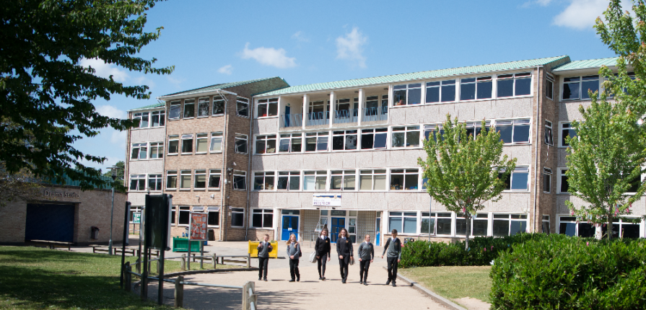

Event | Information | Date
Year 7 First Day | Students will be given their timetable and attend their lessons | Tuesday 3 September 2019
Year 7 Parents’ Evening | Opportunity to discuss with Tutors, students’ progress and their strive for excellence | Wednesday 9 October 2019

Welcome from the Year 7 Team

Your journey with us starts here!

We have very high expectations for each of you, and we hope you have high expectations of what you can expect from us and from our school.
We challenge you to each be the best you can be, so our year group is the best it can be.

Our Year 7 ethos is to ‘Strive for Excellence’ we will achieve this by each setting clear and ambitious targets. We will challenge you to work hard in school and at home, to immerse yourself in the life of the school and to enjoy yourself.
We look forward to seeing you in September!

Mrs Joynson
Head of Year

Miss Bone
Deputy Head of Year

Mrs Lock
Assistant Headteacher
Linked to year 7

A very warm welcome to Brune Park and the GFM!
You are starting an exciting journey, and we want your journey to be a positive and successful one; where you love and value learning, where you further develop as a thoughtful, well-rounded and empathetic young person, where you achieve strong qualifications so you have ‘open doors’ to what you want to study post 16 and future employment.
This all starts from your Transition Days, into September and for your next 5 years …
We’re delighted you are joining the Brune Park GFM community - where you can be proud of who you are and what you can be, where though hard work you will achieve beyond where you can possibly imagine, where you will proud to say ‘I am Brune Park!’

Mrs Andrew-Power
Head Teacher
a

Mr Jones
Associate
Head Teacher

Strive for Excellence

Resilience  We believe in you, we want you to believe in yourself and believe that you can achieve more than you imagine possible.  We are here to provide you with experience at school so you can do that – we will work hard, and we expect you to work hard. The ethos for Year 11 is that ‘hard works, works’ and it does.  At Brune Park you will be challenged, you will find things tough at times, and you will learn to embrace challenge and have the resilience to overcome or work through anything tricky. Building resilience is part of you growing as a learner and as a person. We set high expectations of you and of each other to lay the foundations for your success. | High expectations of yourself  What does it mean to have high expectations of yourself?  We expect you to be the best you can be, all of the time, so:  Strive for excellent time keeping every lesson, every day. Attend school every day, aim for an attendance figure of at least 98%  Be prepared with full equipment every day: School bag, Pencil case, Full set of equipment, School books, Timetable  Wear your uniform with pride  Have a positive and respectful approach and to school, to learning and the community. Bea respected and respectful ‘citizen’ of the school and the Gosport community, making positive contributions to your Year Group, Tutor Group and House.
High expectations of your learning  What does it mean to have high expectations of yours learning?  We expect you to be the best you can be, all of the time, so we expect your work to reflect effort and commitment.  Enjoy your learning and take pride in every piece of work you do. Be proud of your books and your learning and show this pride through your work.  Make every minute of every lesson and homework count for example; always complete written work in full, using full sentences, correct punctuation, grammar and spelling.  Be a student who enjoys and values reading. | High Aspirations  Have really high expectations of yourself and what you want to achieve in life.  Where do you see yourself in 5 years time?  We want you to start thinking about that now!  You will be like most Brune Park students looking to join the 6th Form or college, for A level of higher level study at age 16. Ready for University or higher level apprentice work and study from 18.  Or join the group of students who start a higher level apprenticeship in work age 16.  Or will you be one of our students who joins the Navy or Army or Air Force? Some join at 16, most join with further qualifications at 18, after they have attended university.

Strive for Excellence
Your journey starts now!
Year 11
You will be exam ready
You will be making your choices for 6th Form or Colleges or Apprenticeships
Year 10
Your exam study begins in full, you will be knowledgeable and highly skilled ready for your next stages of study.

Year 9
You select your ‘options’ thinking about your future career path.
You begin to recognise where your talents and interests lie.

Year 8
You will be fully immersed in your learning and the life of the school – trying new things every day.

Year 7
First steps to success

Embrace every opportunity for learning, and every opportunity to join a club or society
‘Proud to be Brune Park’
What are some of our ex-students doing now?

