Dear Parents and Carers

We cannot quite believe we are in the penultimate week of the Academic Year, having marked the achievements and finishing of our Year 11 students with a memorable leavers day including a final assembly and a spectacular Prom hosted by HMS Sultan. It has been a significant year for the students, staff and community of Brune Park. We would like to take this opportunity to thank you as a school community for the incredible support we have received from you throughout the year - and particularly the support, encouragement, care and guidance you have provided to your children who attend our school. We have enjoyed working with so many of you through this year in support of your children and look forward to continued productive partnerships into the next academic year.

Recently appointed student leadership team 2019 - 2020:

We were delighted to receive so many applications from our current Year 10 students for the student leadership posts. We were then challenged given the quality and calibre of applications and their performance throughout the interview and selection process.

We were pleased to find ourselves in the position where we needed to rethink and extend our student leadership teams for the next academic year because of the quality of students so keen to take on leadership responsibilities. The teams will be updating the website with further details of their work soon.

Our thanks and congratulations to:

Head Boy and Girl Andrew Gamble and Phoebe Tunmore
Deputy Head Girl and Boy - Mackenzie Kerr and Jack Thorpe
Assistant Head Girl and Boy - Wellbeing focus - Teigan Jones and Brandon Emerson
Assistant Head Boys and Girls - Positive Profile focus - William Dobbie, Connor Taylor
Emma Merchant-Locke, Emma Penney.

There are also a number of students taking on Senior Prefect roles - more details to follow.

Welcoming our new students from Year 6

We have been delighted to welcome our new students for September who will be joining us in year 7. We have held the transition evening for children with their parents and carers and the three transition days this week. Our ‘new’ students have had a fantastic three days and made a superb first impression on all of us – we’re looking forward to welcoming you full time in September.

Student reports

These will be sent home by email next week. There is a great and easy to access VLOG which talks through what the school reports mean - this can be found here: https://brunepark.gfmat.org/student-reports/

Alternatively please use the information on the website to help you understand in full what your child’s report is showing you. https://brunepark.gfmat.org/parents-and-carers/your-childs-report/

https://brunepark.gfmat.org/contact-us/ this page contains all the information you need in order to make contact with the right member of staff depending on questions you may have from your child’s report.

Headship Assemblies:

We held Headship Assemblies so we could talk to students in each year group - to reflect on this academic year and to look forward to next.

We are very pleased to report that we are fully staffed with specialist teachers in every area from September, and shared with students that we will be retaining our focus on relentlessly high expectations for teaching, learning and engagement.

We revisited the same messages that students have heard throughout the year: that high standards coupled with high expectations, will ultimately lead to fantastic outcomes for our students. We are honest with the students that we expect them to be the best version of themselves at all times and to work hard - 'hard work works' was a phrase that our Year 11 students used all year and were sharing across the school.

In order to be the best version of themselves, we challenged students to think of how they would like to be viewed at an interview for the 6th form, college, university, a job or an apprenticeship. We asked students to have a clear picture of how they would want to come across to people they didn't know but whom they were looking to impress. During follow-up conversations with many of the students, it is clear to see the very high expectations they have of themselves which we are extremely proud of, as we know you are. We will continue to work tirelessly to support them to achieve their goals and high ambitions.

To enable us to support the highest of expectations, a number of other 'operational' issues were shared with the students for the remainder of this year and into next year:

Uniform
We expect students to wear uniform in full and to wear uniform to reflect their pride at being a Brune Park student. Our new PE kits have been designed and chosen by the students and are already making an appearance, and students have fed back that they like being able to wear plain black trainers or shoes, and like that they can choose the style of their plain black trousers.

To bring our uniform approach and expectations in line with other GFM schools and schools nationally, from September students will be required to have a plain coat for school. Hoodies, sweatshirts or tops other than a school jumper will no longer be accepted at school or on the way to school, and will not be acceptable as a coat alternative. We have shared with students this improvement in uniform expectations.

We are very grateful to you; as the vast majority of parents and carers ensure your sons and daughters are in school every day proudly in full uniform. Thank you for your continued support of our uniform expectations for your child into the next academic year.

For full uniform details please visit our website: https://brunepark.gfmat.org/parents-and-carers/uniform/

Health, well-being and the environment

We have provided water coolers across the school site for students to fill water bottles for use throughout the day. Students have worked hard with the team at school to minimise our use of plastics and to promote the positive benefits of drinking water throughout the day. From September we expect students to have their own water bottle with them each day. To coincide with this and in line with other GFM schools and schools nationally, we are no longer permitting fizzy drinks or chewing gum on the school site.

Students have been instrumental in challenging us to raise chewing gum and fizzy drinks as an issue for our school. Chewing gum is not disposed of appropriately and can be found under desks, chairs and embedded in the carpets and on floors around the school. Bottles of fizzy drinks (often up to 2litre bottles) are brought onto the site with students telling us that they have bought the drink on the way to school (many say their parents are not aware they buy these products). These drinks are cheap and easily available in local shops, they are full of sugar and can make it difficult for students to concentrate and remain focussed. Students want us as a community to be healthier, reduce plastic waste and improve the school environment - chewing gum or drinking fizzy drinks is not in keeping with these expectations for the school or with students being the best version of themselves at all times.

There are a number of student groups who from September are also supporting the school to reduce our paper usage, encouraging everyone in the school to take greater pride in school books and producing work in books not on work sheets. Students want to ensure the school reduces the amount of money and resource spent on photocopying, reduce paper wastage and in doing so improve the quality and quantity of work produced in school books.

Cycle and scooter safety

We are delighted that so many Brune Park students cycle or scoot to school and are pleased to report that we are continuing to grow our provision for bike storage and security on site. We strongly encourage students to wear a helmet as they cycle to and from school and ask that parents and carers also emphasise this important safety message.
We have spoken to the students about why there is a very strict ‘no cycling or scooting on the school site’ policy, going through why we have to keep ourselves and others safe on the school site. Bikes and scooters must be pushed when on the school site.

The vast majority of our students conduct themselves superbly well each and every day and are a credit to themselves and their families; we are extremely proud of them all. We are committed to supporting all students to be the very best that they can be and preparing them for life-after-school and their post-16 pathway. This is a continuous process from the time they join us in Year 7 until they sit their final GCSE exam in year 11.

Increased opportunities in the school day

We also shared with students that we have been working on the structure of the school day. This has been in response to a number of factors:

- A desire for more opportunities for enrichment activities during the school day (not ‘just’ reliant on after school)
- More students and staff wanting to run clubs and societies as part of the Brune Park experience
- More students and staff wanting to work across teams to deliver clubs and societies
- Desire to improve student well being with less stress to queue and eat quickly
- Desire to provide all students with the opportunity to access hot or cold food in Footlights at each break
- Securing a more positive school environment around the site at break times
- Bringing in the option of an off-site privilege pass for Year 11

From September there will be the following changes:

- each year group will have one day a week when they have an early finish - this time can be used for extra activities in school, support with homework, clubs or societies, or to go home for additional family time

Monday - Year 7
Tuesday - Year 8
Wednesday - Year 9
Thursday - Year 10
Friday - Year 11

- The school day will begin with lesson 1 and learning from 8.30
- Tutor time will be in the middle of the day
- There is a dedicated clubs and societies period in the middle of the day
- There will be a rolling break programme to take place while lessons continue - this will mean all students can access hot or cold food in Footlights
- There will be a dedicated lunchtime for years 7 and 8
- There will be a dedicated lunchtime for Years 9 and 10 - again ensuring all students can access food in Footlights if they want to
- We can facilitate these changes with no loss to learning time (we hope learning time will be enhanced because students have been able to take a proper break and eat - as with staff.)

We are going through the changes with students in detail through this week - further details will also be posted on the website. The newly structured school day:

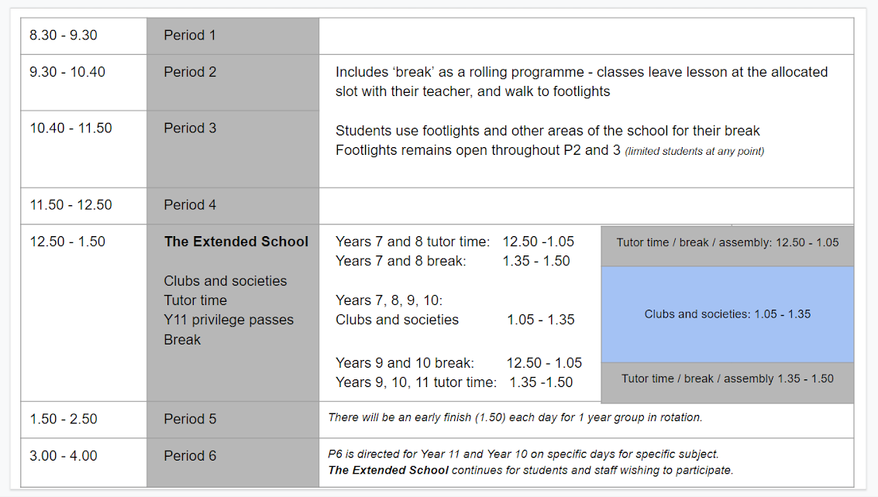

Our thanks again for your support this year, Brune Park and the school community is a very special place to work and to be, we feel privileged to be here working alongside such fantastic young people and their families.

We wish you all a safe and enjoyable summer and look forward to seeing the students back and raring to go in September.

Kirstie Andrew-Power and Mike Jones

