A message from Head girl and boy: Phoebe and Andrew
Stay informed

Dear students and parents
With so much in the media, and on social media about the covid-19 or coronavirus, we want to be sure students and parents of the Brune Park community have easy access to accurate and factual information about the virus, and know about measures we are taking in response to the threat.
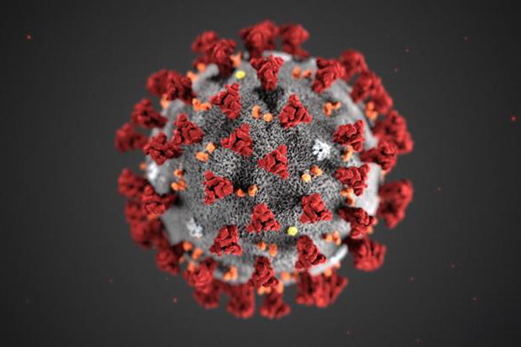
We have been gathering the questions and queries being asked across the year groups, and met with Mrs AP and Harvie (year 7) to go through these and write a response to you so you have facts ( not misleading fiction) and so you know the planning that goes on behind the scenes at school if a ‘threat’ like this happens.

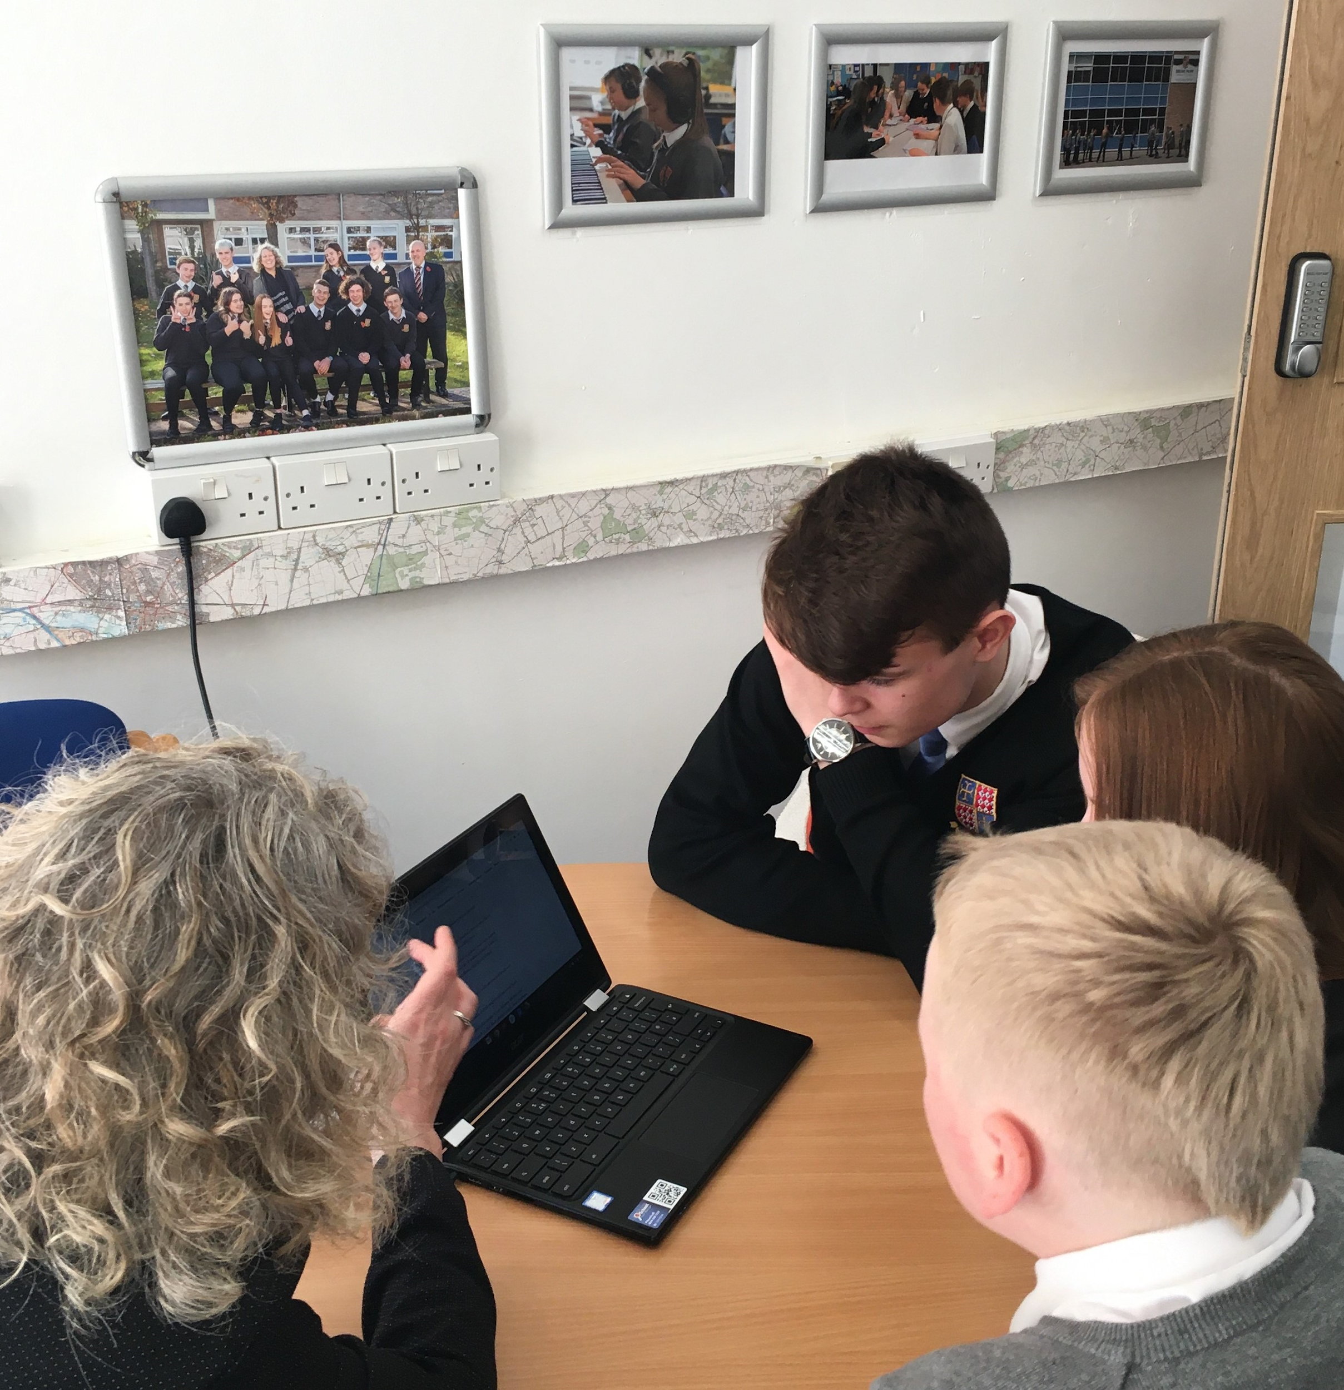

We’ve been through our conversation and hope this summary is helpful:

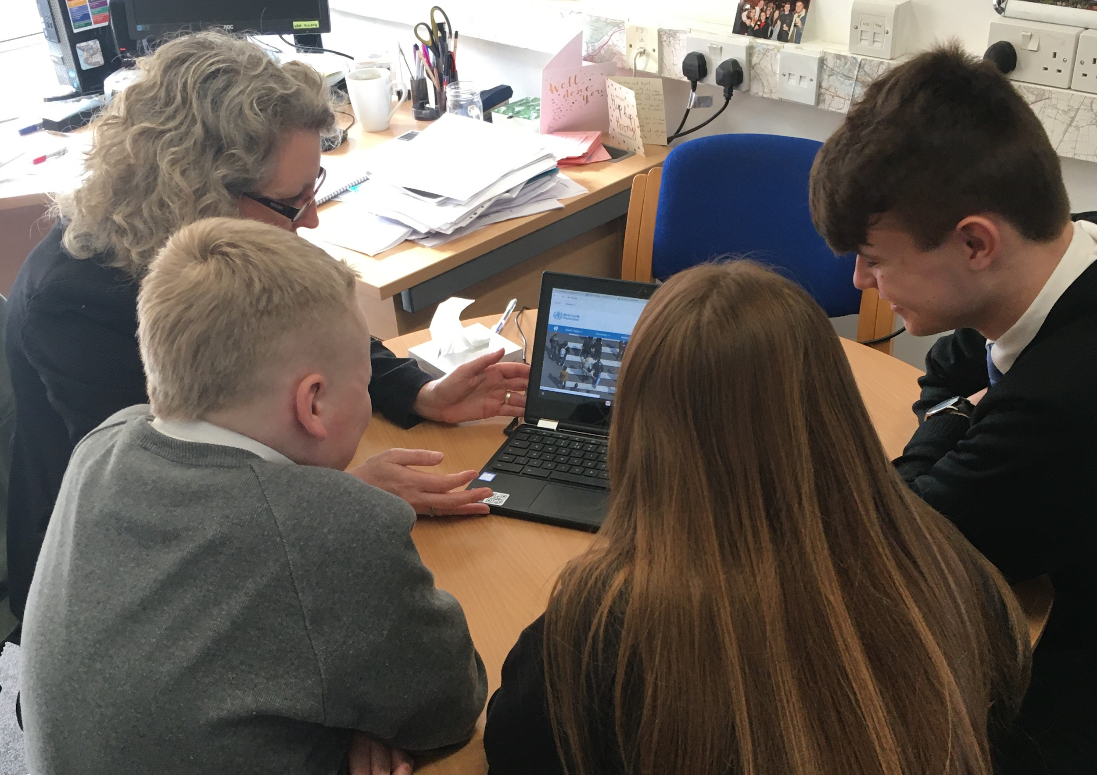
Hi Mrs AP
Thank you for meeting with us today so we can ask you lots of questions and queries we have had from students about the threat of the coronavirus, and how the school with the support of the GFM respond to this threat.
I think it is important that students see that adults in the school (and other students) are not worrying about things unnecessarily. So that the focus is on making sure we know facts, that we’re well informed and regularly informed, and that we know there is planning in place for as many different situations that might occur as possible.
Actually we probably don’t really need to know there is planning in place, I think what’s more important is that students know to think: is this a fact?
One of the reasons I’m not worried, is that I’ve looked things up and tried to look at sources that are reliable and sensible. I’m not being rude but when you see a headline that is all dramatic like: ‘100s will die from covid-19’ I think it's silly and unhelpful and can make people feel like they should be worried. I think what we have to do at school is help people ask questions about whether something is fact or whether it is a silly headline. And I think lots of students are talking sensibly about taking precautions through good hygiene.
Yes because I had to reassure my mate that he doesn’t have the coronavirus. He had a sniffle but he was really worried, he’d been reading stuff on social media and the ‘hype’ really worried him. I had to reassure him.
What did you say to him? How did you know what to say?
I looked stuff up on the internet but tried to look at official things rather than social media or newspaper headlines. What I found out was that we are a low risk area in Gosport so he is very low risk because he hasn’t travelled anywhere, and he doesn’t know anyone who has traveled to an affected area.
I told him that those with stronger immune systems are often fine, so most students if they did contract it would be fine. From what I’ve read most students, staff at school, our families would be fine. Those at higher risk are elderly and young babies. I think the message is quite clear: most people who get the virus are unwell for a few days and then fully recover quite quickly.
Which websites do you think are reliable?
I think the World Health Organisation, NHS, Department for Health.
I get regular emails from the Department for Education which I think are reliable and helpful, on there there are web links that take you through to reliable advice and guidance.
Can we have a look?
Yes this is good, easy to use and they seem to be reliable sources. Let’s paste it so students and parents can see what advice the school is given. (we’ve shared the most recent ones in full at the end of the conversation.)

What do you think are the risks to school?
I think probably at this stage the highest risk is everyone panicking and getting hyped up. I feel quite proud that our students aren’t doing that at all. Look at the questions and queries, they’re all really sensible, reasonable and thoughtful.
So we can actually ask students to keep doing what they’re doing; ask sensible questions, being measured, thinking ‘is that fact or fiction’ thinking ‘what are the actual risks.’ And staff!
Yes I think at Brune Park we are modelling a sensible approach. That is students families and staff - let’s encourage people to keep doing that. I’ve been impressed that students at Brune Park have been sensible and pretty relaxed about the virus, there hasn’t been any silly panicking but lots of scintillating questions!
Yes, what causes the worry is ‘fake news’ what we want this conversation to do is give everyone ‘permission’ to be confident in finding out facts and thinking about whether something they hear is fake or not. I’ve been really pleased with how calm students have been because it is really hard hearing the media ‘hype’ and not reacting in an inappropriate way.
Like I said, I think lots of students are talking sensibly about taking precautions through good hygiene. So washing hands thoroughly, not coughing over each other, I think websites like the NHS have good, factual advice for that.
And taking extra precaution if you know you have travelled to an affected area, or there is a risk that you may have come into contact with someone who has travelled to an affected area and has symptoms. There are lots of sensible links in the email pasted below about what to do in these situations.

I think if there is a case in Gosport, or we have a case in school what is important is that everyone is calm and takes sensible precautions.
Yes, and as a school, that we have robust plans in place.
Yes but not because we think we’re going to need to, but because we want to be confident that if it does happen we are well prepared, with a good mindset about what we will do, why we will do it and being together in how we do it.
Have you been making plans ‘in case’ Mrs AP?
Yes we have made a number of plans, and we’ve made those plans exactly as you’ve said; being confident about what might be needed and how we would do that, having the mindset of being prepared and confident in our approach. And of course, our plans are across the GFM, working with lots of headteachers locally and nationally,taking advice from reliable sources and making sure we are updating our advice and plans often.
How do you prioritise?
Actually it is by behaving as you say we are proud everyone here is: being sensible, thoughtful and measured, considering good hygiene and prevention; thinking first and foremost about people and their health and their well-being.
Yes so for year 11 it is interesting, if there is an outbreak in Gosport we are thinking about making sure everyone is able to work, stay focused on preparation for exams and things, as well of course about health.
So it is all about being calm and sensible, thinking ‘good hygiene’ and having factual and actual information and acting on that in a measured way.
Mrs Hillawi and the Science team have offered to work with groups of students so that we have easy access to information, perhaps for lessons in Science and across the curriculum.
That’s a good idea so students know wherever they are accessing information about the virus in school, we have a group of students and a group of Science staff ‘fact checking’ the accuracy of information. That’s a good idea. Let’s do another one of these for students and staff so we have a Brune Park ‘here’s the facts.’
So what will be our ‘top tips’ for students, families and staff of Brune Park in their approach to covid-19
Keep being sensible and seeking facts
Don’t believe sensationalist headlines in newspapers
Continue taking sensible hygiene precautions
Use reliable sources to keep yourself regularly updated on the advice and guidance and follow it in a measured and thoughtful way.

Here’s the most recent emails from the Department for Education that we hope you’ll find helpful:

We are continuing to keep you updated on the government’s response to COVID-19 (Coronavirus).

Department for Education Coronavirus helpline
Today, we have launched a new helpline to answer questions about COVID-19 related to education. Staff, parents and young people can contact the helpline as follows:
Phone: 0800 046 8687
Email: DfE.coronavirushelpline@education.gov.uk
Opening hours: 8am to 6pm (Monday to Friday)
- No school should close in response to a suspected (or confirmed) COVID-19 case unless directed to do so by Public Health England.

The importance of hygiene
Personal hygiene is the most important way we can tackle COVID-19. Please help us in sharing simple and effective hand hygiene messages.
Public Health England has a dedicated webpage with a range of posters and digital materials at:
https://campaignresources.phe.gov.uk/resources/campaigns/101-coronavirus-/resources
Sign up is quick, free and means you will be alerted as more resources are made available.
We are continuing to keep you updated on the government’s response to COVID-19 (Coronavirus). Public Health England advises that the risk to individuals in the UK remains low.

Advice for those who have travelled recently
Yesterday, the Chief Medical Advisor for England, Chris Whitty updated advice for travellers returning to the UK from specific areas affected by COVID-19, which you can find at:
https://www.gov.uk/coronavirus
Please share this guidance with your staff and cascade as appropriate.
If you have returned from the following specific areas since 19th February, you should call NHS 111 and stay indoors and avoid contact with other people even if you do not have symptoms:
- Iran, Specific lockdown areas in Northern Italy (see link to maps below) Special care zones in South Korea (see link to maps below)
- Hubei province (returned in the past 14 days – see link to maps below)
https://publichealthmatters.blog.gov.uk/2020/01/23/wuhan-novel-coronavirus-what-you-need-to-know/
If you have returned from the following areas since 19 February and develop symptoms, however mild, you should stay indoors at home and avoid contact with other people immediately and call NHS 111:
- Northern Italy (defined by a line above, and not including, Pisa, Florence and Rimini – see link to maps below)
- Vietnam
- Cambodia
- Laos
- Myanmar
If you have a cough, or fever or shortness of breath and have visited any of the following areas in the last 14 days, stay indoors and call NHS 111 informing them of your recent travel:
- China, apart from Hubei province (see link to maps below)
- Thailand
- Japan
- Republic of Korea, apart from special care zones (see link to maps)
- Hong Kong
- Taiwan
- Singapore
- Malaysia
- Macau

Maps showing affected regions of China, Republic of Korea and Italy
https://www.gov.uk/government/publications/covid-19-specified-countries-and-areas

Advice for those who have travelled recently in a group, such as a school trip There is no need to manage returning groups any differently. Pupils, students and staff returning from trips to the countries specified above should follow the same advice.

