Year 8

Entrance

Yr 8 only bike store

Bike Parking Sign with Symbol, A4 (210mmx297mm): Amazon.co.uk: Kitchen &  HomeBike Parking Sign with Symbol, A4 (210mmx297mm): Amazon.co.uk: Kitchen &  HomeBike Parking Sign with Symbol, A4 (210mmx297mm): Amazon.co.uk: Kitchen &  Home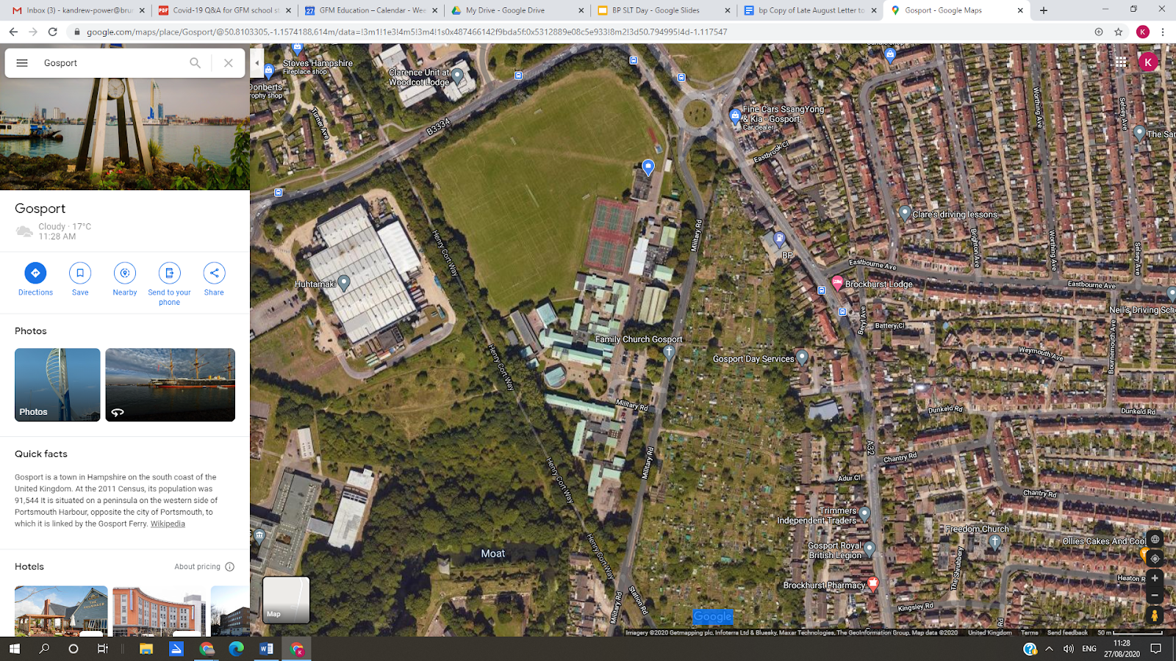

Year 7

Entrance

Y7 only bike store

Y9, 10, 11

bike store

Entrances

Year 9 and 11 (right)

Year 10

(left)